KPMG Virtual Internship Program

**Sprocket Central Pty Ltd**, client of KPMG, a medium size bikes & cycling accessories organisation, has approached Tony Smith (Partner) in KPMG’s Lighthouse & Innovation Team. Sprocket Central Pty Ltd is keen to learn more about KPMG’s expertise in its Analytics, Information & Modelling team. 

Smith discusses KPMG’s expertise in this space (you can read more [here](https://home.kpmg/au/en/home/services/advisory/management-consulting/digital/data-analytics-modelling.html)). In particular, he speaks about how the team can effectively analyse the datasets to help Sprocket Central Pty Ltd grow its business.

Primarily, Sprocket Central Pty Ltd needs help with its customer and transactions data. The organisation has a large dataset relating to its customers, but their team is unsure how to effectively analyse it to help optimise its marketing strategy. 

However, in order to support the analysis, you speak to the Associate Director for some ideas and she advised that “the importance of optimising the quality of customer datasets cannot be underestimated. The better the quality of the dataset, the better chance you will be able to use it drive company growth.”

The client provided KPMG with 3 datasets:

1. Customer Demographic
2. Customer Addresses
3. Transactions data in the past 3 months

You decide to start the preliminary data exploration and identify ways to improve the quality of Sprocket Central Pty Ltd’s data.

Sprocket Central Pty Ltd is a long-standing KPMG client whom specialises in high-quality bikes and accessible cycling accessories to riders. Their marketing team is looking to boost business by analysing their existing customer dataset to determine customer trends and behaviour.

The dataset was based upon the analysis on customer details and demographics.

It is important to keep in mind the business context when presenting your findings:

* What are the trends in the underlying data?
* Which customer segment has the highest customer value?
* What do you propose should be Sprocket Central Pty Ltd ’s marketing and growth strategy?

What additional external datasets may be useful to obtain greater insights into customer preferences and propensity to purchase the products?

Specifically, your presentation should specify who Sprocket Central Pty Ltd’s marketing team should be targeting out of the new 1000 customer list as well as the broader market segment to reach out to.

**GRAPHICAL REPRESENTATION**:

Diagram 1:

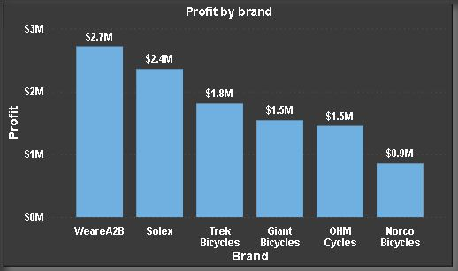

The analysis on Brand in respect to Profit and it shows that WeareA2B generates $2.7M followed by Solex with $2.4M so on and so forth.

Diagram 2:

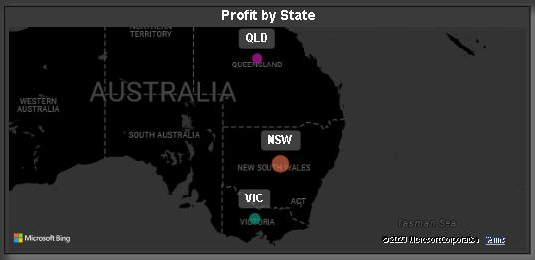

The Mapping visual shows the profit in terms of State categories such as Victoria, New South Wales and Queensland. New South Wales being the highest generating state.

Diagram 3:

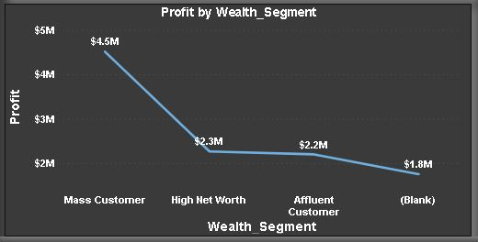

The Line chart being implemented on Wealth segmentation in terms of Profit where we can analyse that Mass Customer generating $4.5M followed by High Net Worth of $2.3M, Affluent Customer of $2.2M.

Diagram 4:

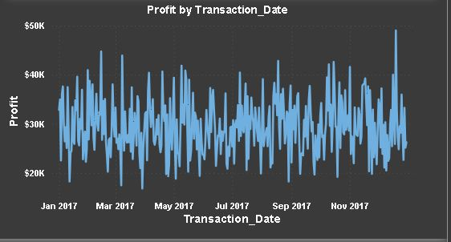

The Date hierarchy on monthly basis being shown from Jan 2017 to Nov 2017.

Diagram 5:

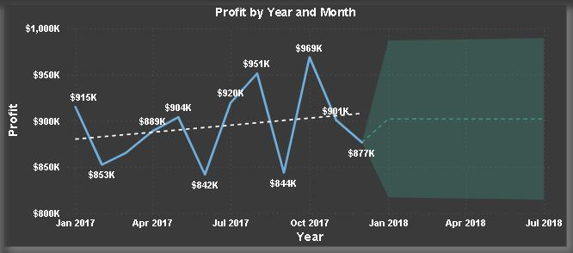

The Forecasting analysis being implemented for 10 days in Year and Monthly basis in respect to Profit to see the streamline along with value. The line is in increasing trend.

Diagram 6:

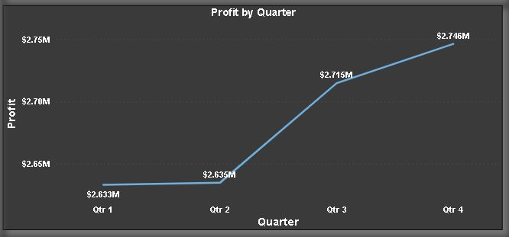

The line chart is being implemented on quarterly basis where we can see the 4th Quarter from Oct to Dec having the highest profit with $2.75M followed by 3rd Quarter with $2.72M.

Diagram 7:

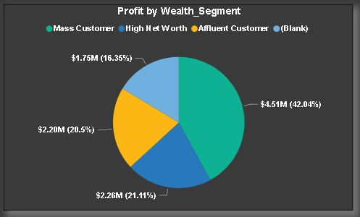

The Pie Chart being used for Wealth Segment in terms of Profit. Wealth Segment categorised into 3 parts like Mass Customer, High Net Worth and Affluent Customer having different and variant percentage and value of profits.

Diagram 8:

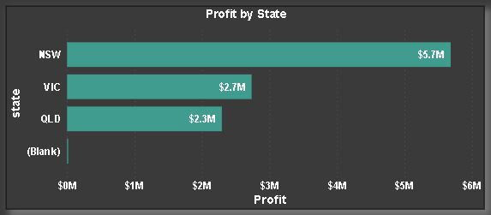

Bar Chart being used for Profit by State where New South Wales generate $5.7M profit followed by Victoria with $2.7M and Queensland with $2.3M.

Diagram 9:

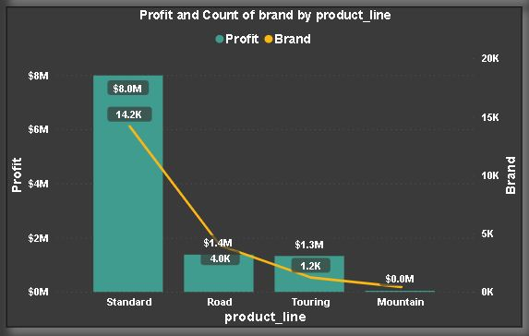

The Line and Column combo chart being used to check on different Product Line in respect to profit – Standard being the highest with $8.0M along with secondary axis having brand with $14.2K connected to Product Line with profit section followed by Road, Touring.

Diagram 10:

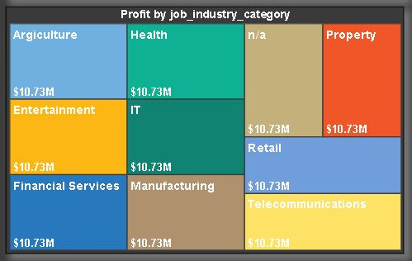

DATA INSIGHTS

Dear Client,

Thank you for providing 3 sets of datasets from “**Sprocket Central Pty Ltd**”, The summary table shows in the below is related to all issues faced in given datasets. Please do look into it and revert back to me if anything changes required.

|  |  |  |  |
| --- | --- | --- | --- |
| KPMG Virtual Internship Dataset |  |  |  |
| Transactions | Removing Blanks. | Profit Column being created. | Unwanted column deletion. |
| Customer Demographic | Removing Blanks. | Age column created. | Gender data being replaced with proper validation. |
| Customer Address | State column being replaced with proper validation. | Removal of unwanted columns. | Remove errors and checking data type. |

All necessary changes being done and issues has been resolved to make a well and structured data.

Recommendations given below:

* Gender diversity and consistency provided
* Age columns being added for customers.
* Removing errors and blank cells of rows.
* Profit column being created and RFM Analysis done in excel.

This are all necessary changes being made to create proper dataset.

Best Regards

Rishi Kalpa Mukherjee